Billedgloser 4 – Træk billederne ind i de rigtige bokse!

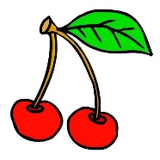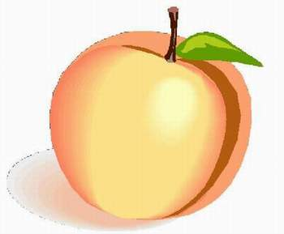

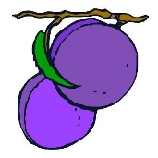

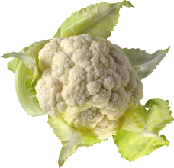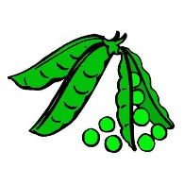

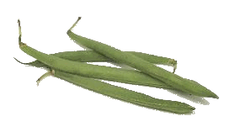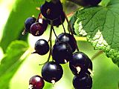

|  |  |  |  |  |  |
| --- | --- | --- | --- | --- | --- |
|  |  |  |  |  |  |
| cauliflower | peach | onion | cherries | plums | strawberry |
|  |  |  |  |  |  |
| blackcurrants | beans | nut | cucumber | peas | carrots |

Scroll ned for løsning!

Løsning 4

|  |  |  |  |  |  |
| --- | --- | --- | --- | --- | --- |
|  | http://www.vskrems-lerchenfeld.ac.at/arbeitsmaterialien/anlautbilder/pfirsich.jpg | Løg, Vegetabilsk, Mad, Sund, Frisk, Organisk, Vegetar |  |  |  |
| cauliflower | peach | onion | cherries | plums | strawberry |
| http://www.swr.de/imperia/md/images/swr4/bw/ratgeber/2003/103.jpg | http://www.waynescomputerworld.com/Dotti/Images/Vegetables/haricotverts.gif | Hasselnød, Vektor, Tegning, Frugt, Møtrik, Brun |  |  |  |
| blackcurrants | beans | nut | cucumber | peas | carrots |